

**PROJECT PROPOSAL**

**SEMESTER SEVEN**

**COLLEGE NOTES CATALOG**

**BY:**

**SANDESH BAJRACHARYA (C30105210052)**

**BACHELOR OF INFORMATION & COMMUNICATION TECHNOLOGY**

**SCHOOL OF SCIENCE & TECHNOLOGY**

**ASIA e UNIVERSITY**

Table of Contents

Abstract iv

List of Figures v

List of Tables vi

CHAPTER 1 1

INTRODUCTION 1

1.1 Background 1

1.2 Problem Definition 3

1.3 Objectives 4

1.4 Scope and Limitations 4

1.5 Target User 5

1.6 Project Timeline 5

CHAPTER 2 6

LITERATURE REVIEW 6

2.1 Introduction 6

2.2 Development of Proposed System 6

2.3 Review of Existing Systems 7

2.4 Methodology 10

CHAPTER 3 12

SYSTEM ANALYSIS 12

3.1 Functional Requirements 12

3.1.1 Manage Users 12

3.1.2 Manage Notes 12

3.1.3 Manage Repositories 12

3.2 Use Case Diagram 13

3.3 Non Functional Requirements 14

3.4 Feasibility Analysis 16

3.5 Process Modeling 17

3.5.1 Context Diagram 17

3.6.1 Decision Tree and Decision Table 18

3.7 Conceptual Modeling 19

3.7.1 ER Diagram 20

Chapter 4 21

SYSTEM DESIGN 21

4.1 FLOWCHART 21

4.2 INPUT-OUTPUT DIAGRAM 22

4.3 USER INTERFACE STRUCTURE 22

4.4 DATABASE DESIGN 22

4.4.1 Data Dictionary 22

i. Users 22

ii. Subjects 22

iii. Chapters 23

iv. Repository 23

v. Access 24

4.5 DETAILED DESCRIPTION OF COMPONENTS 25

4.5.1. NAVIGATION BAR 25

4.5.2. HOME PAGE 25

4.5.3. ADMIN DASHBOARD 25

4.5.4. SUBJECT LISTING PAGE 25

4.5.5. CHAPTER EDIT PAGE 25

4.5.6. CHAPTER DETAIL PAGE 25

4.6 TOOLS USED 26

CHAPTER 5 27

CONCLUSION 27

5.1 Conclusion 27

5.2 Future Enhancement 27

Appendix 28

# Abstract

## List of Figures

Figure 1: GANTT CHART 4

Figure 2: Agile Methodology 9

Figure 3: Use Case Diagram 12

Figure 4: Context Diagram 16

Figure 5: DFD Level 1 16

Figure 6: Decision Tree of User Input 17

Figure 7: Flowchart of Entire System 19

Figure 8: Entity Relationship Diagram (ERD) 23

Figure 9: Entity Relationship Diagram (ERD) 23

## List of Tables

Table 1: Comparison Table 7

Table 2: Decision Table 18

# CHAPTER 1

# INTRODUCTION

## Background

Students often struggle to access comprehensive study materials and final year project repositories. A centralized platform, accessible to both university students and external individuals, is needed to provide reliable and approved academic resources, enhancing learning and collaboration.

Access to quality academic resources is crucial for student success. The College Notes Catalog addresses this need by offering a centralized, digital platform where students can access a wide range of study materials, including notes, lecture summaries, and textbooks. Additionally, it features an approved final year project repository, accessible to both university students and external users. This repository not only serves as a valuable learning tool but also fosters collaboration and innovation. By providing a publicly accessible, organized collection of academic resources, the College Notes Catalog enhances the educational experience and supports academic excellence. It will be used by the following groups:

* University Students: They use the platform for accessing study materials and collaborating on projects.
* External Users: Individuals outside the university can access the final year project repository for reference or collaboration.

The main feature of the College Notes Catalog is its comprehensive, digital repository of academic resources, including notes, lecture summaries, textbooks, and final year projects. This repository is not only accessible to university students but also to external users.

The technology stack for the College Notes Catalog includes several elements. The programming languages used are NodeJS and JavaScript. The markup language is HTML, and the style sheet language is CSS. The web frameworks employed are Tailwind and ReactJS. The database is run on MySQL, and the server used is a Node Server.

## Problem Definition

A significant problem students often face is the difficulty in accessing comprehensive study materials and project repositories. Often, individuals have the knowledge and skills but struggle to find academic resources that align with their learning objectives due to the vast and unorganized nature of academic materials. This lack not only prolongs the learning process but also leads to missed opportunities for both students and external individuals.

1. Difficulty in Accessing Comprehensive Study Materials and Project Repositories
2. Lack of a Centralized Platform for Academic Resources
3. Need for Collaboration Among Students and External Individuals

The College Notes Catalog aims to address these issues by offering a centralized, digital platform where students can access a wide range of study materials, including notes, lecture summaries, and textbooks. By doing so, the platform ensures that students and external individuals are provided with reliable and approved academic resources. This approach streamlines the learning process and enhances the chances of academic excellence. By organizing and prioritizing academic resources based on individual learning needs, the platform reduces the time and effort required to find relevant academic materials, benefiting both students and external users.

## Objectives

The College Notes Catalog aims to effectively address the challenges faced by students and external users through the following key OBJECTIVES:

1. Centralize Academic Resources

2. Facilitate Access to Project Repositories

3. Enhance Learning Process

4. Foster Collaboration

5. Support Academic Excellence

College Notes Catalog aims to enhance the learning experience, support academic success and foster collaboration among students and external users.

## Scope and Limitations

Scope:

1. Offer a wide range of academic resources, including notes, lecture summaries, textbooks, and final year projects.
2. Serve a diverse set of users, including university students and external users.
3. Facilitate collaboration among students and between students and external users.
4. Streamline the learning process by organizing and prioritizing academic resources based on individual learning needs.

Limitations:

1. Depends on the active participation of students and external users to contribute and update academic resources.
2. The quality and usefulness of resources can vary, as they are user-submitted.
3. While the platform is designed to be user-friendly, there may be a learning curve for some users to navigate and utilize the platform effectively.
4. Ensuring the privacy and security of user data can be challenging.

## Target User

* + - 1. Age Group: 18-55
      2. Interest: Students seeking for college notes, inspirations and references for final year project.
      3. Education: +2 Passed and IT Undergrad Students
      4. Profession: Students, IT Coordinators, Teachers

## Project Timeline

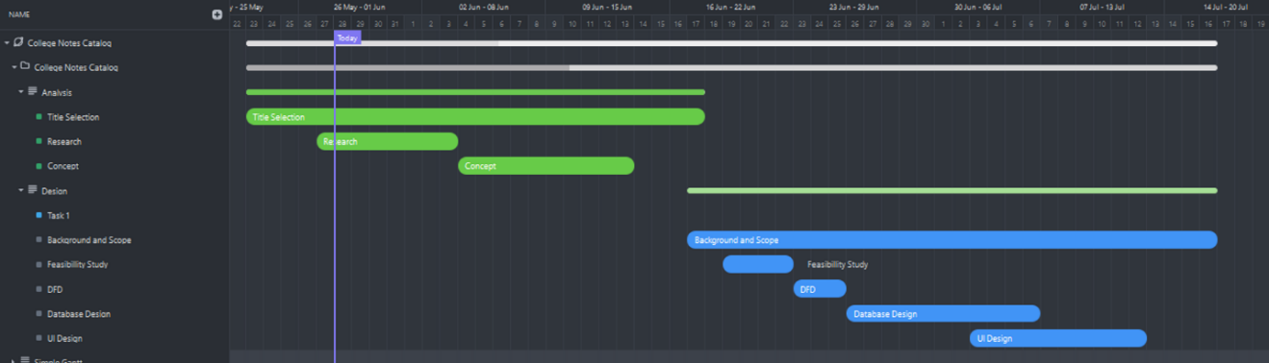

Figure 1: GANTT CHART

# CHAPTER 2

# LITERATURE REVIEW

## 2.1 Introduction

The College Notes Catalog aims to bridge this gap by providing a user-friendly platform for students to share and access valuable learning materials. This chapter delves into existing research on student-created learning resources and collaborative learning environments to establish the theoretical foundation for the proposed system.

## 2.2 Development of Proposed System

College Notes Catalog effectively addresses student needs and delivers value quickly by utilizing the Agile development methodology. Agile prioritizes flexibility and rapid iteration. This means we'll work closely with users and stakeholders to define the platform's core functionalities and continuously refine them based on feedback. The project will be broken down into manageable phases, allowing for frequent delivery of features and adjustments based on real-world use. This iterative approach ensures the College Notes Catalog evolves alongside user needs, guaranteeing a platform that truly empowers students, educators, and external users.

The chosen technology stack, including Node.js, JavaScript, HTML, CSS, and MySQL, provides the necessary scalability and flexibility to accommodate the anticipated growth in users and uploaded resources.

This approach fosters continuous improvement and user engagement, ensuring the College Notes Catalog remains a relevant and valuable tool for the academic community.

## 2.3 Review of Existing Systems

#### **INSCRIBE - College Notes Sharing Application**

The "INSCRIBE - College Notes Sharing Application" by Priyanshi Jaiswal and Rashi Wadnerkar focuses on enhancing student access to educational materials through a secure, user-friendly platform. The application features user authentication, robust search functionality, and file upload capabilities supporting PDF, DOC, and PPT formats. It significantly reduces the manual efforts involved in note distribution, providing a streamlined and efficient learning environment for students (Jaiswal & Wadnerkar, 2022). The front-end of INSCRIBE utilizes HTML, CSS, and JavaScript, enabling a dynamic and responsive user interface. The back-end is managed using PHP, which processes server-side requests, and MySQL, which handles database operations. This combination ensures that the system is both robust and scalable, capable of handling large volumes of data and multiple user interactions simultaneously.

Furthermore, INSCRIBE incorporates a notification system to alert users about new uploads and updates, fostering a real-time collaborative environment. This feature is particularly beneficial in maintaining student engagement and ensuring that they have access to the latest study materials. The system's design also emphasizes user privacy and data security, with secure login protocols and encrypted data transmission. These features collectively contribute to a comprehensive notes-sharing solution that addresses the core needs of students and educators alike.

#### **Notes Sharing Web Portal**

The "Notes Sharing Web Portal" by Piyush Pathade et al. addresses the inefficiencies of manual note distribution through a centralized, secure system for both students and teachers. This web portal features role-based access, where students and teachers can register and manage their notes. The approval system for uploaded notes ensures that only high-quality and relevant materials are accessible, improving the reliability of the content (Pathade et al., 2022). The portal's synchronization feature across devices ensures that users can access their notes anytime and anywhere, enhancing the flexibility and convenience of the system.

Technologically, the Notes Sharing Web Portal employs HTML, CSS, and JavaScript for the front-end, creating a responsive and intuitive interface. The back-end is powered by PHP, which efficiently handles server-side logic, while MySQL manages the relational database, ensuring data integrity and security. The system's design incorporates data encryption and secure login mechanisms to protect user data. Additionally, the portal includes advanced search functionalities, allowing users to quickly find specific notes based on various criteria such as subject, author, or format. This feature is particularly useful during exam periods when students need quick access to specific information.

**Comparison of Features**

|  |  |  |  |
| --- | --- | --- | --- |
| **Feature** | **GroupNotes** | **Notes Sharing Web Portal** | **Proposed System (College Notes Catalog)** |
| **Primary Objective** | Enhance student engagement | Secure online note sharing | Centralized digital repository |
| **Technologies Used** | NodeJS, operational transformation | JavaScript | NodeJS, ReactJS, MySQL |
| **Key Features** | Real-time synchronization | Document uploads, search functionality | Digital repository of academic resources |
| **Interaction Capabilities** | Real-time collaboration | Admin-managed approvals | Facilitate collaboration among users |
| **Pedagogical Impact** | Increased student engagement | Enhanced study efficiency | Streamline learning process |
| **Challenges Addressed** | Student disengagement | Manual paperwork | Lack of centralized academic resources |
| **Limitations** | Smartphone dependency | Internet dependency | User-contributed content quality |

Table 1: Comparison Table

**Conclusion**

Lecture Management System and GroupNotes by Mark Reilly and Haifeng Shen, alongside the Notes Sharing Web Portal by Piyush Pathade et al., represent significant advancements in educational technology. Each system addresses distinct challenges in content distribution, student engagement, and resource management within educational settings. However, they also exhibit limitations related to interactivity, technological dependencies, and data security. The proposed College Notes Catalog aims to integrate the strengths of these systems by offering a centralized digital repository while fostering collaboration and accessibility among students and external users. This review underscores the evolution and ongoing efforts in leveraging technology to enhance educational experiences and outcomes.

## 2.4 Methodology

The College Notes Catalog embraces the Agile development methodology to deliver a learning platform that is both effective and responsive to the evolving needs of students, faculty, and external users. Agile development departs from traditional, linear approaches, prioritizing flexibility and rapid iteration. This translates to a collaborative environment where user feedback and stakeholder input are woven into the very fabric of the system's development.

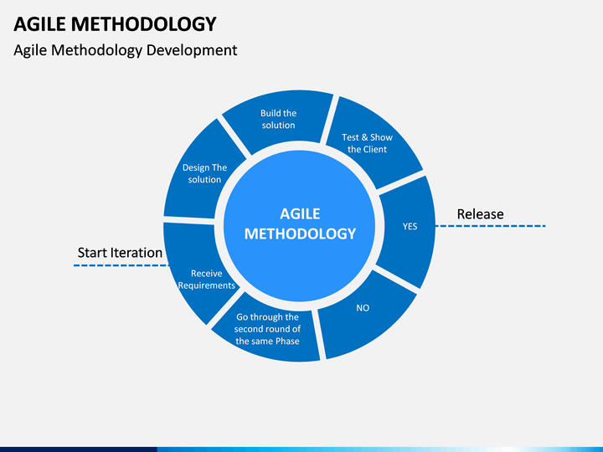

Figure 2: Agile Methodology

At the core of Agile lies the concept of sprints, short, focused development cycles. Each sprint tackles a specific set of functionalities, ensuring early delivery of value to the user community. This iterative approach allows users to experience the platform's capabilities early on, providing vital feedback that informs subsequent development cycles. By continuously refining features based on real-world use, the College Notes Catalog can address unforeseen challenges and adapt to emerging user needs. This ensures the platform remains relevant and addresses the most pressing academic resource requirements.

The College Notes Catalog leverages Agile's emphasis on collaboration to foster a dynamic learning ecosystem. Regular communication channels are established between developers, students, faculty, and external users. This allows stakeholders to voice their needs and concerns, while developers gain a deeper understanding of how the platform is being utilized. This collaborative spirit fosters a sense of ownership and investment, ensuring the College Notes Catalog evolves alongside the academic community it serves. By harnessing the power of Agile, the College Notes Catalog transcends a static repository of resources, transforming into a living, breathing platform that empowers academic success.

# 

# CHAPTER 3

# SYSTEM ANALYSIS

## Functional Requirements

### 3.1.1 Manage Users

* + 1. The system shall allow a SuperAdmin to create, read, update and delete (CRUD) user accounts.
    2. The system shall authenticate users logging into the system.
    3. The system shall assign user roles (e.g., student, teacher, SuperAdmin)

### 3.1.2 Manage Notes

1. The system shall allow students and teachers to upload notes, lecture summaries, and other approved academic resources.
2. The system shall allow students and teachers to CRUD notes and lecture summaries that they uploaded.
3. The system shall allow students to search for notes and lecture summaries based on various criteria (e.g., course, subject, keyword).

### 3.1.3 Manage Repositories

* + 1. The system shall allow teachers to upload final year projects.
    2. The system shall allow SuperAdmin to manage (CRUD) final year project repositories.
    3. The system shall allow students and external users to search for final year projects based on various criteria (e.g., department, keyword).

## 3.2 Use Case Diagram

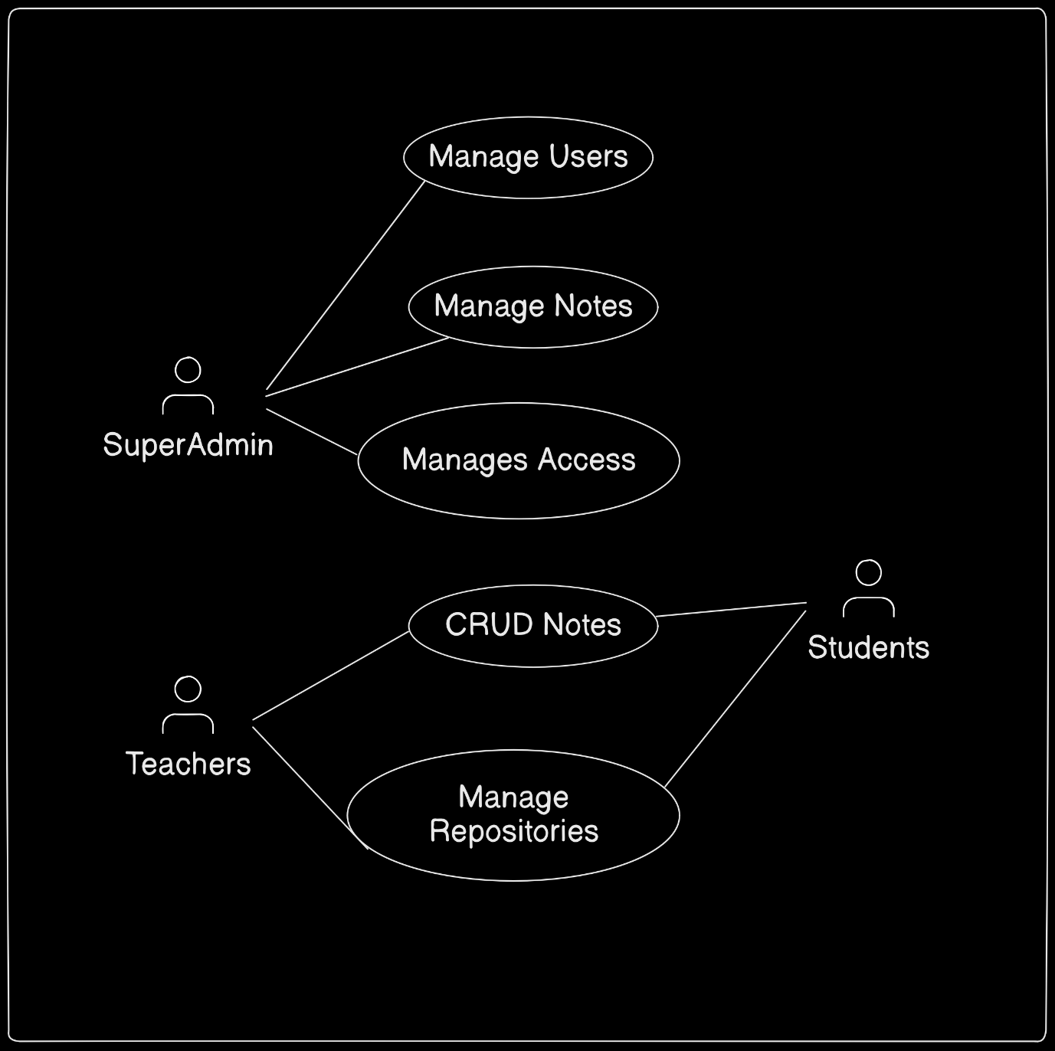

Figure 3: Use Case Diagram

## 3.3 Non Functional Requirements

The College Notes Catalog prioritizes a set of non-functional requirements that cultivate a robust and dependable platform for both students and faculty. These requirements ensure a seamless learning experience, fostering academic excellence and collaboration.

* + - 1. Performance: The College Notes Catalog delivers exceptional performance, minimizing page load times and ensuring rapid response to user actions, even during periods of high user concurrency. This responsiveness translates to a frustration-free learning environment where students can focus on acquiring knowledge without technical interruptions.
      2. Scalability: The platform is architected with scalability in mind. It anticipates a growing user base and an expanding repository of academic resources. The College Notes Catalog seamlessly adapts to accommodate this growth, maintaining optimal performance and user experience regardless of the increasing volume of data.
      3. Reliability: Unwavering availability is a cornerstone of the College Notes Catalog. The system boasts minimal downtime, ensuring consistent access to critical learning materials for students and faculty contributions. Regular backups and a well-defined disaster recovery plan safeguard data integrity and guarantee system accessibility in the face of unforeseen circumstances.
      4. Portability: The College Notes Catalog leverages a technology stack that prioritizes platform independence. This allows for effortless deployment on various servers or cloud platforms, should future needs necessitate such a migration. This flexibility ensures the system can adapt to evolving technological landscapes without significant disruptions to ongoing academic activities.
      5. Security: The College Notes Catalog prioritizes the security of sensitive user data and uploaded resources. It implements robust security measures that include multi-factor user authentication, granular access controls that restrict unauthorized access, and industry-standard encryption techniques that protect data confidentiality.
      6. Usability: The College Notes Catalog fosters a user-centric environment through an intuitive and user-friendly interface. Designed with clarity and simplicity in mind, the interface caters to users with varying levels of technical expertise. A well-organized navigation system, a powerful search function with customizable filters, and clear labeling of functionalities all contribute to a smooth user experience. This user-friendliness maximizes the system's effectiveness as a learning and collaboration tool for the entire academic community.

By prioritizing these non-functional requirements, the College Notes Catalog establishes a foundation for a seamless learning experience, empowering students and faculty to achieve academic excellence.

## 3.4 Feasibility Analysis

1. Economic Feasibility: The economic viability of the College Notes Catalog hinges on a cost-benefit analysis. Development costs associated with the technology stack and ongoing maintenance must be weighed against the potential benefits. These benefits include improved student learning outcomes, increased faculty productivity, and potential cost savings for the university through reduced reliance on physical learning materials.
2. Operational Feasibility: The operational feasibility of the College Notes Catalog requires an assessment of its integration into existing university workflows. The system's user management processes, content moderation protocols, and access control mechanisms must align with the university's policies and procedures. Furthermore, a dedicated team with the necessary technical skills and expertise will be needed to manage the platform's ongoing operation and user support.
3. Technical Feasibility: The technical feasibility of the College Notes Catalog revolves around the chosen technology stack's ability to deliver the desired functionalities. The scalability of the chosen technologies must be evaluated to ensure they can accommodate the anticipated growth in users and uploaded resources. Additionally, the technical expertise available within the university or through potential partnerships with external vendors must be sufficient to develop, deploy, and maintain the platform effectively.

## Process Modeling

### Context Diagram

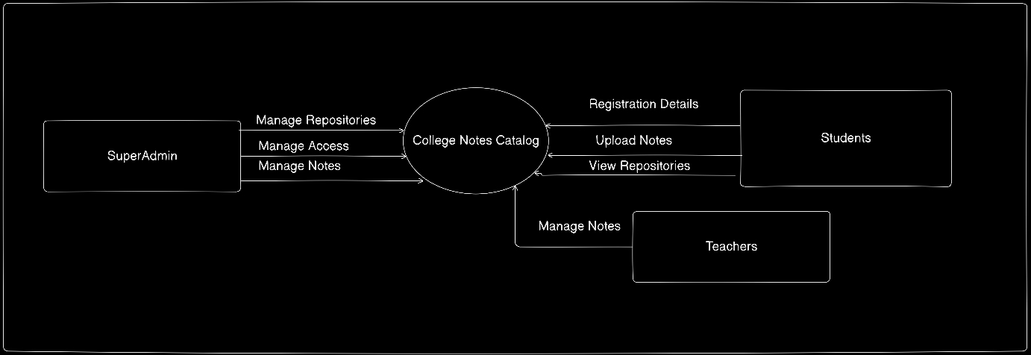

Figure 4: Context Diagram

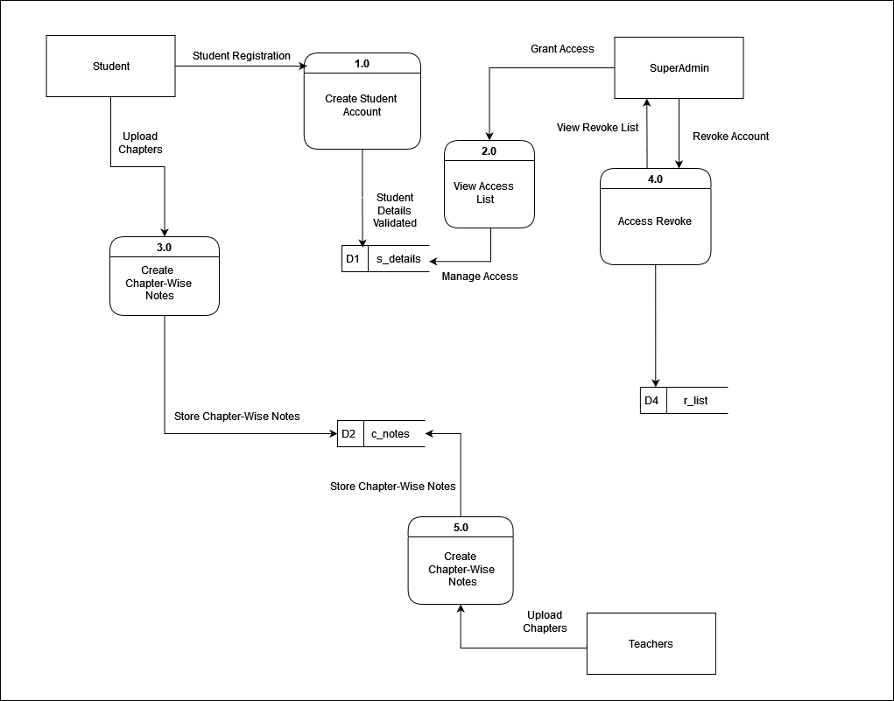3.5.2 Data Flow Diagram (DFD) Level

Figure 5: DFD Level 1

* 1. Logic Modeling

### 3.6.1 Decision Tree and Decision Table

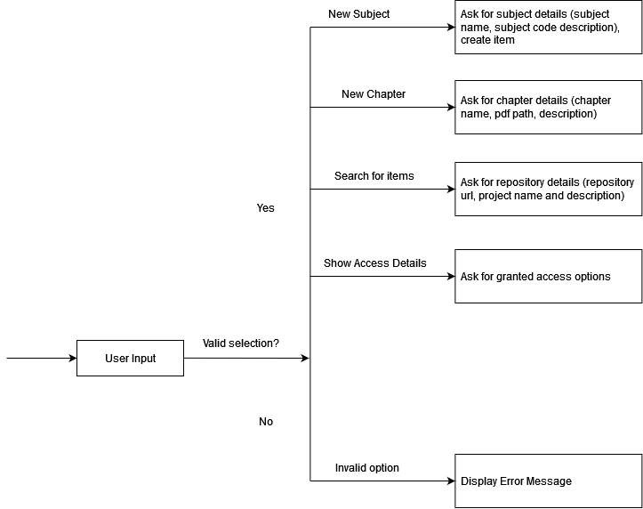

Figure 6: Decision Tree of User Input

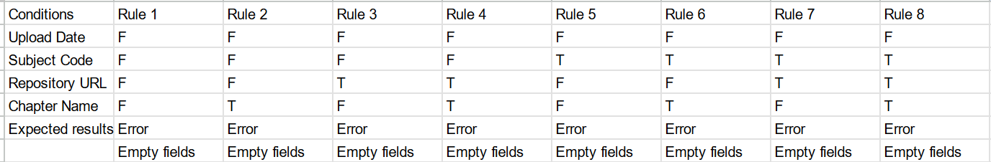

|  |  |  |  |  |
| --- | --- | --- | --- | --- |
| **Conditions** | **Rule 1** | **Rule 2** | **Rule 3** | **Rule 4** |
| **Username** | F | T | F | T |
| **Password** | F | F | T | T |
| **Expected Results** | Error: Username or password is incorrect. | Error: Password is incorrect. | Error: Username is incorrect. | Success: User is logged in. |

Table 2: Decision Table

### 3.7 Conceptual Modeling

### 3.7.1 ER Diagram

### C:\Users\Sandesh\AppData\Local\Microsoft\Windows\INetCache\Content.Word\erd.drawio.png

Figure 8: Entity Relationship Diagram (ERD)

# Chapter 4

# SYSTEM DESIGN

## 4.1 FLOWCHART

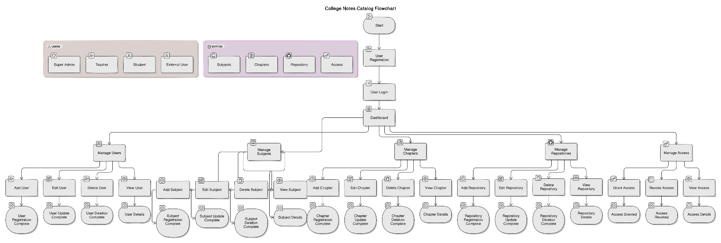

Figure 7: Flowchart of Entire System

## 4.2 INPUT-OUTPUT DIAGRAM

## USER INTERFACE STRUCTURE

## 4.4 DATABASE DESIGN

### 4.4.1 Data Dictionary

### Users

**Purpose**: To store information about users, including university students, external users, and super admins.

|  |  |  |
| --- | --- | --- |
| **Column Name** | **Data Type** | **Constraints** |
| **user_id** | INT | PRIMARY KEY, AUTO_INCREMENT |
| **username** | VARCHAR | NOT NULL, UNIQUE |
| **email** | VARCHAR | NOT NULL, UNIQUE |
| **password_hash** | VARCHAR | NOT NULL |
| **role** | ENUM | NOT NULL (values: 'student', 'external', 'admin') |
| **created_at** | TIMESTAMP | DEFAULT CURRENT_TIMESTAMP |

### 

### Subjects

**Purpose**: To store information about the subjects offered.

|  |  |  |
| --- | --- | --- |
| **Column Name** | **Data Type** | **Constraints** |
| **subject_id** | INT | PRIMARY KEY, AUTO_INCREMENT |
| **subject_name** | VARCHAR | NOT NULL, UNIQUE |
| **subject_code** | VARCHAR | NOT NULL, UNIQUE |
| **description** | TEXT |  |

### 

### Chapters

**Purpose**: To store information about chapters within subjects.

|  |  |  |
| --- | --- | --- |
| **Column Name** | **Data Type** | **Constraints** |
| **chapter_id** | INT | PRIMARY KEY, AUTO_INCREMENT |
| **subject_id** | INT | FOREIGN KEY REFERENCES Subjects(subject_id) |
| **chapter_name** | VARCHAR | NOT NULL |
| **pdf_path** | VARCHAR | NOT NULL |
| **uploaded_at** | TIMESTAMP | DEFAULT CURRENT_TIMESTAMP |
| **uploaded_by** | INT | FOREIGN KEY REFERENCES Users(user_id) |
| **description** | TEXT |  |

### 

### Repository

**Purpose**: To store information about the GitHub repositories related to final year projects.

|  |  |  |
| --- | --- | --- |
| **Column Name** | **Data Type** | **Constraints** |
| **repository_id** | INT | PRIMARY KEY, AUTO_INCREMENT |
| **repository_url** | VARCHAR | NOT NULL, UNIQUE |
| **project_name** | VARCHAR | NOT NULL |
| **description** | TEXT |  |
| **created_at** | TIMESTAMP | DEFAULT CURRENT_TIMESTAMP |
| **created_by** | INT | FOREIGN KEY REFERENCES Users(user_id) |

### 

### Access

**Purpose**: To manage user access to notes and projects.

|  |  |  |
| --- | --- | --- |
| **Column Name** | **Data Type** | **Constraints** |
| **access_id** | INT | PRIMARY KEY, AUTO_INCREMENT |
| **user_id** | INT | FOREIGN KEY REFERENCES Users(user_id) |
| **note_id** | INT | FOREIGN KEY REFERENCES Notes(note_id) |
| **access_type** | ENUM | NOT NULL (values: 'view', 'edit', 'download') |
| **granted_at** | TIMESTAMP | DEFAULT CURRENT_TIMESTAMP |

## 4.5 DETAILED DESCRIPTION OF COMPONENTS

### 4.5.1. NAVIGATION BAR

The navigation bar exists on all pages to provide quick access to its functions. The left side of the navigation bar contains the logo of the College Notes Catalog. At the right side is a search bar that lets the user immediately search for notes and subjects in the database with various keywords.

### 4.5.2. HOME PAGE

The Home page will have the hero section with the navigation bar and a welcome message. Since the target users are college students, each section of the home page will detail the functions of the application and how to use them. To that end, the page will have sections to describe the app's purpose, how it works, a call to login to use the application, contact details for help, and the footer to conclude it.

### 4.5.3. ADMIN DASHBOARD

The dashboard page exists for the admin side to view various analytics. The dashboard will have shortcut buttons to view various assorted lists of subjects, chapters, and users. It will also have a more comprehensive search bar with filters and sorting options for managing the catalog system.

### 4.5.4. SUBJECT LISTING PAGE

The subject listing pages will be accessible through the dashboard and separate pages will be available for different listing needs. The page will have access to extensive searching features with filters and various keywords associated with the subjects and chapters. To avoid clutter, the list will be managed by pagination.

### 4.5.5. CHAPTER EDIT PAGE

The chapter edit page will be accessible from the details page and will allow the admin to edit every detail of a previously entered chapter. Moreover, it will also have a module to upload or update PDF files. It will also have help details in case the users are having issues.

### 4.5.6. CHAPTER DETAIL PAGE

The details page will be accessible from the listing page where it opens up details for the selected chapter. It will display the chapter content, associated PDF files, and related information. It will also have the help details in case the users are having issues accessing or understanding the content.

## 4.6 TOOLS USED

|  |  |
| --- | --- |
| **Category** | **Tools Used** |
| 1. Front End | HTML/CSS, Tailwind CSS, ReactJS |
| 1. IDE | Visual Studio Code |
| 1. Database | MySQL: For application of multi-clients. It is used to monitor different clients at once. Every data including the IP addresses, keystrokes, and screenshots are captured in the database. |
| 1. Backend | NodeJS |
| 1. Version Control | Git, GitHub: To provide backup, development, version control, and CICD (Continuous Integration and Continuous Deployment) |
| 1. Project Management | Notion |
| 1. UML Design | Draw.io, Eraser.io |
| 1. UI/UX | Figma |

# CHAPTER 5

# CONCLUSION

## 5.1 Conclusion

The College Notes Catalog system has been successfully designed and implemented to address the needs of college students for efficient note management and sharing. By providing a centralized platform for organizing, accessing, and collaborating on academic materials, the system enhances the learning experience and promotes knowledge sharing among students. The implementation of features such as subject-wise organization, chapter management, and access control ensures that users can easily navigate and utilize the vast repository of notes and study materials.

## 5.2 Future Enhancement

While the current system provides a solid foundation for note management, several enhancements can be made to further improve its functionality and user experience:

1. Mobile Application Development: Create a mobile app version of the College Notes Catalog to provide on-the-go access to notes and study materials, enhancing accessibility for students.
2. Gamification Elements: Introduce gamification features such as badges, points, and leaderboards to encourage active participation and contribution to the note repository.

These enhancements will not only improve the functionality of the College Notes Catalog but also increase user engagement and the overall value of the platform for students in their academic journey.

# Appendix

